**DAILY ONLINE ACTIVITIES SUMMARY**

|  |  |  |  |  |  |  |  |  |
| --- | --- | --- | --- | --- | --- | --- | --- | --- |
| **Date:** | **29-6-2020** | | | | | **Name:** | **Poojashree T** | |
| **Sem & Sec** | **8th sem B sec** | | | | | **USN:** | **4al16cs064** | |
| **Online Test Summary** | | | | | | | | |
| **Subject** | | **SMS** | | | | | | |
| **Max. Marks** | | **60** | | **Score** | | | **Not received Mail** | |
| **Certification Course Summary** | | | | | | | | |
| **Course** | **Introduction to R language tutorial** | | | | | | | |
| **Certificate Provider** | | | **Great learning academy** | | **Duration** | | | **3.0hr** |
| **Coding Challenges** | | | | | | | | |
| **Problem Statement:** **1**. **to read the number and compute the series.**  **2. to count the number in th series.**  **3. to check whether number is palindrome or not.**  **4. to find the number between 0 and 50 which are not divisible by 2 and 3.**  **5.micro and array update**  Top of Form | | | | | | | | |
| **Status:completed** | | | | | | | | |
| **Uploaded the report in Github** | | | | | **yes** | | | |
| **If yes Repository name** | | | | | **Poojatgowda** | | | |
| **Uploaded the report in slack** | | | | | **yes** | | | |

**Online test**

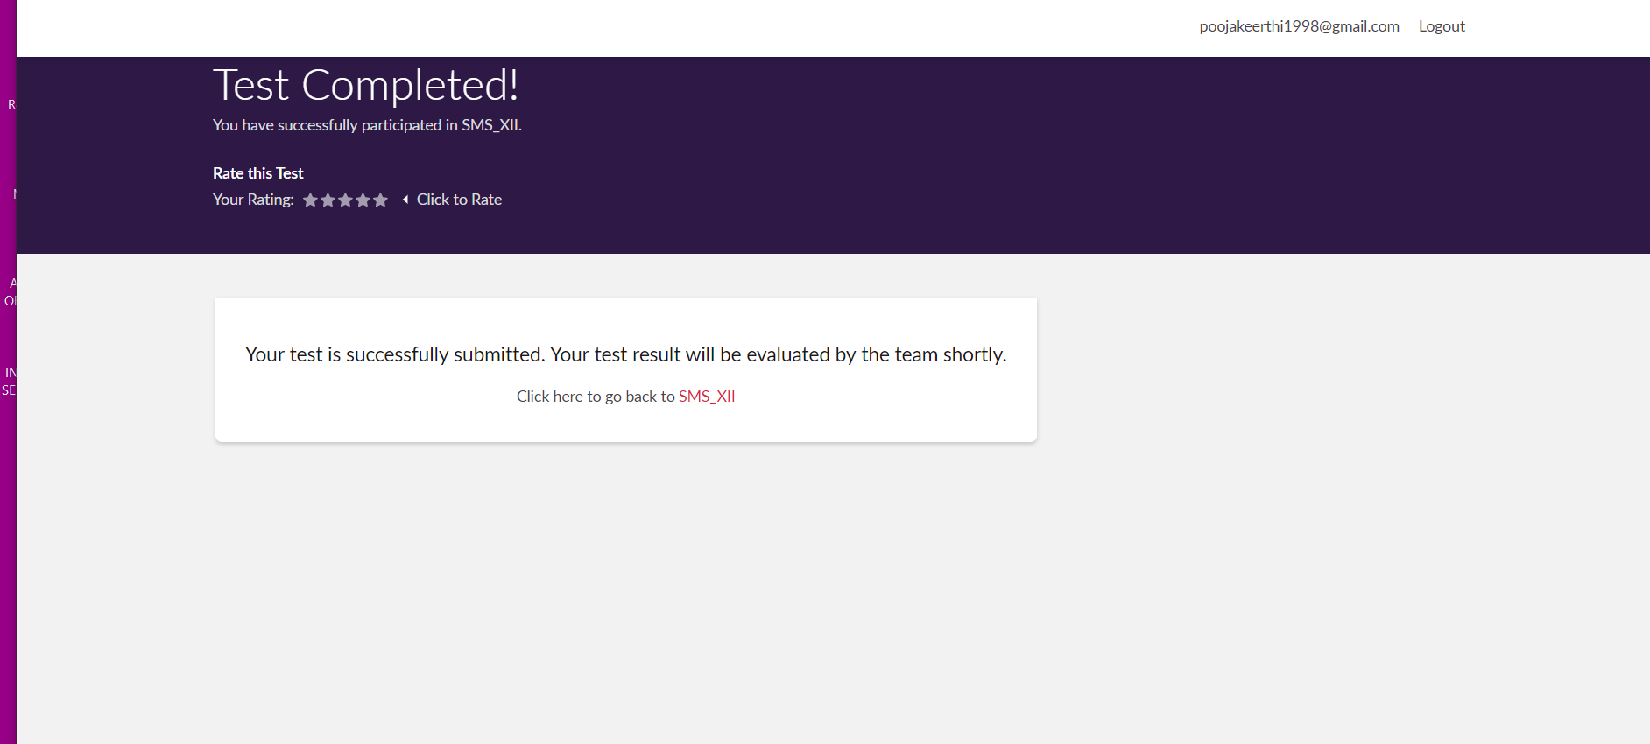

**Certification course**



**Example: Program to check whether input number is prime or not**

**Example Program:**

This program uses [linear search algorithm](https://en.wikipedia.org/wiki/Linear_search) to find out a number among all other numbers entered by user.

/* Program: Linear Search Example

* Written by: Chaitanya from beginnersbook.com

* Input: Number of elements, element's values, value to be searched

* Output:Position of the number input by user among other numbers*/

import java.util.Scanner;

class LinearSearchExample

{

public static void main(String args[])

{

int counter, num, item, array[];

//To capture user input

Scanner input = new Scanner(System.in);

System.out.println("Enter number of elements:");

num = input.nextInt();

//Creating array to store the all the numbers

array = new int[num];

System.out.println("Enter " + num + " integers");

//Loop to store each numbers in array

for (counter = 0; counter < num; counter++)

array[counter] = input.nextInt();

System.out.println("Enter the search value:");

item = input.nextInt();

for (counter = 0; counter < num; counter++)

{

if (array[counter] == item)

{

System.out.println(item+" is present at location "+(counter+1));

/*Item is found so to stop the search and to come out of the

* loop use break statement.*/

break;

}

}

if (counter == num)

System.out.println(item + " doesn't exist in array.");

}

}

Output 1:

Enter number of elements:

6

Enter 6 integers

22

33

45

1

3

99

Enter the search value:

45

45 is present at location 3

Output 2:

Enter number of elements:

4

Enter 4 integers

11

22

4

5

Enter the search value:

99

99 doesn't exist in array.